**DISTRELEC-8330 - Timestamp Import and Export Cronjob**

1. **Checkboxes should be checked while hybris Update -**

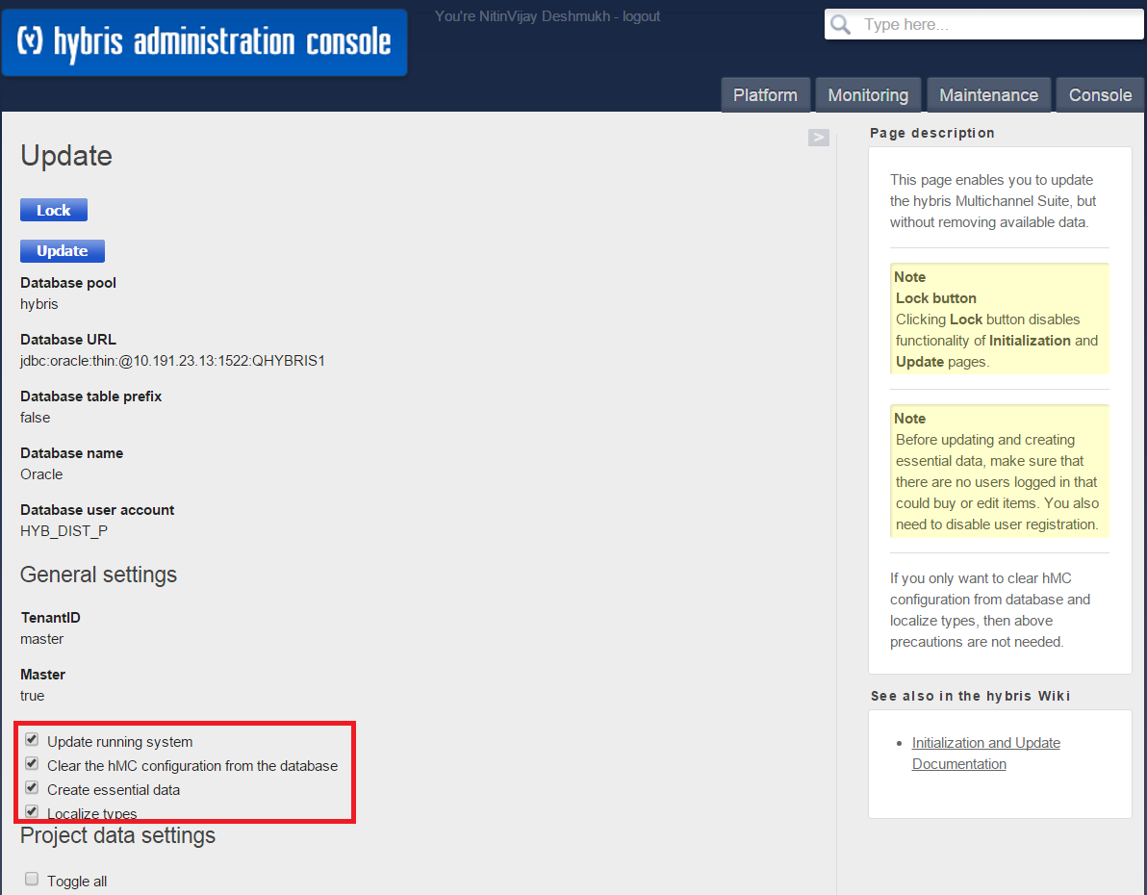

1. **Make Sure “firstAppearanceDatefile” is in right place**

**Check hmc.configuration file in hmc > Under Product Type you will find in Common Section Tab if not then manually add save the hmc configuration.**

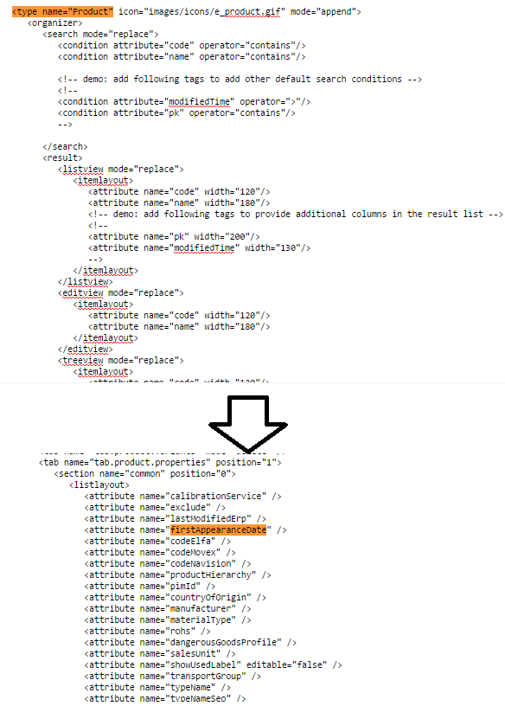

1. **After successfully hybris update create below Cronjob –**
   1. **Timestamp Import Cronjob – Import from file + Incremental update**
2. **Create Cronjob in HMC:**

**System > CronJobs > Create > Select DistUpdateFirstAppearanceDateCronJob form list**

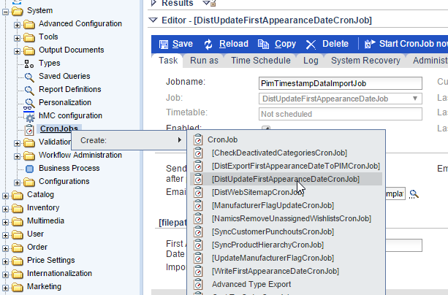

**To import the Data from file –**

1. **First Appearance Date File Path: Here you can provide the complete file path from application server (Node 0). It is mandatory field Please make sure file extension should be .xlsx**
2. **Import From File: Checked the checkbox and It is mandatory to checked**

**Incremental Update -**

1. **Import from File: It should be unchecked for Incremental Update.**
2. **First Appearance Date File Path: No Need to provide the file path but it is optional. As per best practice it should be blank on Production while running Incremental Update**

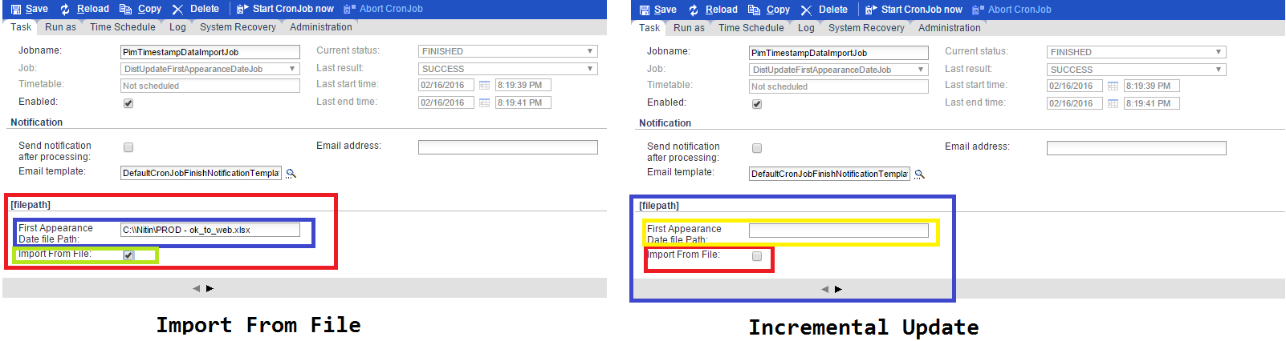

* 1. **Timestamp Export Cronjob – Export file to PIM**

1. **Create CronJob in hmc**

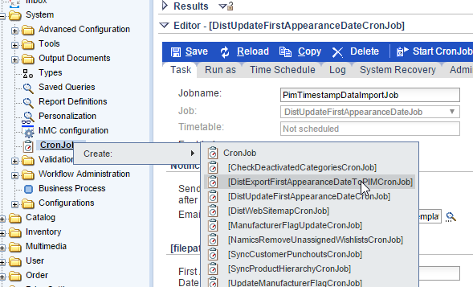

**System > CronJobs > Create > Select DistUpdateFirstAppearanceDateCronJob form list**

1. **Provide the file path below which is mandatory for Export Job. Please make sure file extension should be .xlsx**

